DESSERT

Crème Brûlée - Hallon - Citron…………………………………..….…...135
Tarte med citron crème brûlée, hallon coulis,
saltrostad pistage & färska hallon
Tart with lemon crème brûlée, raspberry coulis, salt-roasted pistachios & fresh raspberries

Jordgubbar - Rabarber - Mandel……………………………….…...135
Jordgubbsmousse, myntamaräng, luftig vaniljcréme,
bakade rabarber, mandelkaka, färska jordgubbar & lime
Strawberry mousse, mint meringue, vanilla, baked rhubarb, Almond Cake, Fresh Strawberries and lime.

Utvalda ostar………………………..……………….………………………….….………..155
Hemgjort fröknäcke & fikonmarmelad
Selected cheese, home made crispbread & fig marmalade

Hemgjord glass eller sorbet……………………..…………………….…..…60
Homemade ice cream or sorbet

Hemgjord tryffel……………….…………………………..……………………………….45
Homemade truffle

SÖTT VIN
Royal Tokaji, Late Harvest gl/………..115/625:-
Moscato d'asti, Ceretto 2021 gl/fl….…125/435:-

KAFFEDRINKAR

Kaffe Karlsson 174
Cointreau, Baileys, kaffe & grädde

Irish Coffee 174
Jameson whiskey, farinsocker, kaffe & grädde

Espresso Martini 174
Absolut vodka, Kahlua & espresso

HotShot 128
Licor 43, kaffe & grädde

KAFFE
Zoegas bryggkaffe 42
Espresso 44/52
Cappuccino 56
Cortado 56
Te 42

AVEC
Zacapa Centenario 23…………………….…………………….….48/cl
Diplomático Reserve 12 Años…………………………….….44/cl
Grappa Sarpa di Poli………………………………..……………....36/cl
Martell VSOP………………………………………………………………….46/cl
Martell Cordon Bleu………………………………………...………..63/cl
Lagavulin 16 Years…..…………………………………….…….…….56/cl
Baileys………………………………………………………………………….……..31/cl

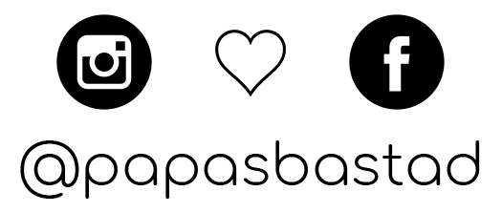

www.papas.nu | 0431-789 89 | Hamngatan 6, Båstad

